Parish of HOLY TRINITY CUCKFIELD
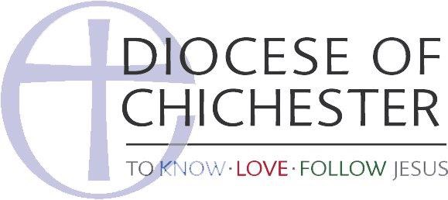
Safe-Space Checks

All areas to be checked before each session
Date: Time: Checked by:

 | Area assessed | Yes | No | Comments/actions
1 | Entrance to Activity Area  - Free of trip hazards  - Exit routes unobstructed  - Electrical sockets free from damage  - Clean and tidy  - External doors locked and / or alarmed  - Lights switched on  - Cleaning cupboard locked
2 | Activity Room  - External doors locked and / or alarmed  - Layout of equipment allows free movement  - Electrical wires positioned safely  - Heaters guarded appropriately  - Clean and tidy  - Toys and play equipment in good order  - Bins lined  - Phone switched on  - First Aid kit accessible  - Room temperature suitable  - Free of trip hazards
4 | Kitchen (if applicable)  - Clean and tidy  - Inaccessible to unsupervised children  - Appliances and equipment positioned safely  - Cleaning products/materials stored securely  - Food stored appropriately  - Fridge temperature within safe range  - Anti-bac soap available for hand-washing
5 | Toilets  - Clean and tidy  - Accessible to all  - Cleared of cleaning products  - Sufficient toilet roll, soap and paper towels  - Hand washing posters in place
6 | All exits  - Cleared of obstructions  - In working order  - Clearly identified
7 | Outside areas  - Entrance safe/ clear of obstruction (eg ice)  - Play area litter-free (inc glass, animal faeces)  - Outdoor equipment in good order and safe to use  - Any workmen/strangers in the play area?  - Gates closed / locked

